

***Tech Saksham***

***Case Study Report***

***Data Analytics with Power BI***

***“Global Terrorism Dataset***

***Analysis Using Power BI”***

***“SRI KUMARA KURUPARA SWAMIGAL ARTS COLLEGE, SRIVAIKUNDAM - 628 619”***

|  |  |
| --- | --- |
| ***NM ID*** | ***NAME*** |
| ***007556CB721F05DB58543453CBE557C4*** | ***V VENGADESH*** |

|  |
| --- |
| ***Trainer Name : R. UMA MAHESWARI*** |
| ***Master Trainer : R. UMA MAHESWARI*** |

***ABSTRACT***

***The GTD provides comprehensive information on terrorist incidents worldwide, including details such as location, target type, attack type, and casualties. Leveraging the visualization capabilities of Power BI, this analysis aims to uncover patterns, trends, and insights within the dataset. The analysis includes interactive visualizations that allow users to explore various aspects of terrorism, including temporal trends, geographical hotspots, and the modus operandi of terrorist groups. Additionally, the study examines the effectiveness of counter-terrorism measures over time and identifies regions most affected by terrorism. The findings of this analysis contribute to a better understanding of the evolving nature of global terrorism and can inform policymakers, researchers, and security agencies in developing strategies to combat this threat.***

# *INDEX*

|  |  |  |
| --- | --- | --- |
| ***Sr. No.*** | ***Table of Contents*** | ***Page No.*** |
| ***1*** | ***Chapter 1: Introduction*** | ***4*** |
| ***2*** | ***Chapter 2: Services and Tools Required*** | ***7*** |
| ***3*** | ***Chapter 3: Project Architecture*** | ***8*** |
| ***4*** | ***Chapter 4: Modeling and Result*** | ***10*** |
| ***5*** | ***Conclusion*** | ***19*** |
| ***6*** | ***Future Scope*** | ***20*** |
| ***7*** | ***References*** | ***21*** |
| ***8*** | ***Links*** | ***22*** |

***CHAPTER 1 INTRODUCTION***

## ***"Welcome to our analysis of global terrorism using Power BI. In today's world, understanding the patterns and trends of terrorism incidents is crucial for effective counter-terrorism efforts. In this dashboard, we'll explore comprehensive data on terrorist attacks worldwide, including their locations, types, motives, and impacts. By leveraging Power BI's robust analytical capabilities, we aim to uncover insights that can inform policymakers, security agencies, and the public about the evolving nature of global terrorism. Let's delve into the data and uncover actionable insights to enhance our understanding and response to this critical global issue."***

## *1.1 Problem Statement:*

***In today's complex global landscape, combating terrorism requires a deep understanding of its multifaceted nature. However, analysts and policymakers are often challenged by the vast amount and rapid pace of terrorist-related data generated worldwide. Traditional methods of analysis struggle to keep pace, resulting in delayed or incomplete insights. This limitation impedes effective decision-making and proactive measures to prevent future attacks. Additionally, the heterogeneous nature of terrorism data, encompassing various attack types, motives, and geographical regions, further complicates analysis efforts.***

## *1.2 Proposed Solution:*

***To address these challenges, we propose the development of a Power BI dashboard tailored for global terrorism analysis. This dashboard will aggregate and visualize real-time data from diverse sources, including incident reports, intelligence agencies, and media outlets. By leveraging Power BI's advanced analytics capabilities, the dashboard will provide a comprehensive view of terrorism trends, hotspots, and patterns. Its***

***Interactive features and customizable functionalities will empower analysts to drill down into specific regions or timeframes, enabling them to identify emerging threats and devise targeted counter-terrorism strategies. Furthermore, the dashboard's real-time analysis capabilities will facilitate timely responses to evolving threats, enhancing national security efforts worldwide.***

## *1.3 Feature:*

***1. Real-Time Analysis: The Power BI dashboard will provide real-time analysis of terrorist attack data.***

***2. Attack Segmentation: It will segment terrorist attacks based on various parameters such as location, attack type, casualty count, etc.***

***3. Trend Analysis: The dashboard will identify and display trends in terrorist attack patterns over time.***

***4. Predictive Analysis: It will utilize historical data to predict potential future terrorist attack hotspots or trends***

## *1.4 Advantages:*

## ***1. Data-Driven Decision Making: Governments and security agencies can make informed decisions based on real-time analysis of terrorism data, enhancing national security.***

## ***2. Proactive Counterterrorism Measures: Understanding terrorist attack patterns and trends can help authorities proactively implement counterterrorism strategies and allocate resources effectively.***

## ***3. Enhanced Public Safety: By identifying high-risk areas or potential targets, security measures can be strengthened to mitigate the threat of terrorism and ensure public safety.***

## ***4. International Collaboration: Sharing and analyzing terrorism data***

## ***through Power BI can facilitate collaboration between countries and international organizations in combating terrorism on a global scale.***

## ***1.5 Scope:***

## 

## ***"The scope of this project encompasses comprehensive analysis of global terrorism incidents, aiming to provide actionable insights for policymakers, security agencies, and researchers. The project will leverage Power BI to explore trends, patterns, and hotspots in terrorism activities worldwide. Additionally, it can be extended to incorporate diverse data sources, including socio-economic indicators, conflict zones, and geopolitical factors, to enhance the understanding of terrorism dynamics. Advanced analytics techniques, such as predictive modeling and correlation analysis, will be employed to uncover hidden patterns and forecast future trends. Furthermore, the project has the potential to be adapted for other domains, such as national security, humanitarian aid, and conflict resolution, where insights into terrorism are essential. Ultimately, this project contributes to global efforts in counterterrorism, promoting data-driven decision-making, and* *enhancing security measures worldwide."***

***CHAPTER 2***

***SERVICES AND TOOLS REQUIRED***

***2.1 Services Used***

***● Data Collection and Storage Services: The primary data source for this analysis is the Global Terrorism Database (GTD), a comprehensive dataset maintained by organizations such as the National Consortium for the Study of Terrorism and Responses to Terrorism (START).***

***● Data Processing Services: GTD provides detailed information on terrorist incidents worldwide, including location, date, attack type, casualties, perpetrators, and more.***

***2.2 Tools and Software used***

***Tools:***

***● Power BI: The main tool for this project is Power BI, which will be used to create interactive dashboards for real-time data visualization.***

***● Power Query: This is a data connection technology that enables you to***

***discover, connect, combine, and refine data across a wide variety of sources.***

***Software Requirements:***

***● Power BI Desktop: This is a Windows application that you can use to create reports and publish them to Power BI.***

***● Power BI Service: This is an online SaaS (Software as a Service) service that you use to publish reports, create new dashboards, and share insights.***

***● Power BI Mobile: This is a mobile application that you can use to access your reports and dashboards on the go.***

# ***CHAPTER 3***

# ***PROJECT ARCHITECTURE***

## ***3.1 Architecture***

***USER* *FRONTEND BACKEND***



|  |  |  |
| --- | --- | --- |
|  | ***HTML 5*** | ***NODEJS 14.0***  ***Database*** |

***1. *Data Collection:* The global terrorism dataset is collected from reputable sources such as the Global Terrorism Database (GTD) or governmental agencies. This data includes information on terrorist incidents, perpetrators, targets, and casualties, and is gathered through extensive research and reporting mechanisms.***

***2. *Data Preparation and Transformation:* Upon collection, the dataset undergoes rigorous preprocessing to address inconsistencies, missing values, and outliers. This ensures the data is clean and formatted correctly for analysis in Power BI. Transformation steps may include data normalization, feature engineering, and merging with supplementary datasets for enriched insights.***

***3. *Data Modeling:* The preprocessed dataset is imported into Power BI Desktop for further analysis. Data modeling techniques are employed to establish relationships between different tables within the dataset, enabling seamless navigation and exploration. Measures and calculated columns are defined to derive meaningful metrics and insights from the data.***

***4. *Data Analysis and Visualization:* Utilizing Power BI's suite of visualization tools, the global terrorism dataset is analyzed to uncover trends, patterns, and correlations. Visualizations such as heat maps, time series charts, and geospatial maps are employed to effectively communicate key findings. Interactive features such as filters and slicers enable users to drill down into specific regions, time periods, or attack types for deeper analysis.***

***5. *Advanced Analytics (Optional):* For enhanced insights, advanced analytics techniques such as clustering, sentiment analysis, or time series forecasting may be applied within Power BI. Integration with external tools or programming languages like R or Python allows for custom analytics and machine learning models to be incorporated into the analysis pipeline.***

***6. *Deployment and Sharing:* The finalized dashboards and reports are published to the Power BI service for online access. Stakeholders and decision-makers can securely access the analysis from any device using Power BI Desktop, Power BI Service, or Power BI Mobile app. Granular access controls ensure that sensitive information is protected and only accessible to authorized users.***

***This architecture provides a robust framework for analyzing the global terrorism dataset using Power BI, enabling stakeholders to gain valuable insights into terrorist activities worldwide. However, it's essential to adapt the architecture to specific project requirements, existing infrastructure, and compliance with relevant data privacy and security regulations.***

***CHAPTER 4***

***MODELING AND RESULT***

# 

# 1. *Establishing Relationships: The GTD likely consists of multiple tables with related information such as terrorist incidents, locations, perpetrators, and attack types. In Power BI, establishing relationships between these tables is crucial to combine data from different sources and perform integrated analysis.*

# *2. Defining Cardinality and Cross Filtering Direction: Understanding the cardinality (one-to-one, one-to-many, many-to-one, many-to-many) and cross-filtering direction between tables is essential. For instance, there may be a one-to-many relationship between the 'Incidents' table and the 'Locations' table, where one incident can occur in multiple locations.*

# ***3. Utilizing Bidirectional Filtering: Depending on*** *the analysis requirements, bidirectional filtering may be necessary. For example, when analyzing terrorism incidents by country, bidirectional filtering allows users to filter incidents by country and also filter countries by incidents.*

# *4. Handling Many-to-Many Relationships:* *In some cases, there might be many-to-many relationships between tables. For instance, multiple perpetrators could be involved in various incidents, and vice versa. Power BI provides techniques such as bridge tables or using DAX functions like 'RELATEDTABLE' to handle many-to-many relationships effectively.*

# *5. Optimizing Relationship Performance: Optimizing relationships is crucial for efficient data retrieval and visualization. Power BI offers features such as using inactive relationships, creating bi-directional filters selectively, and avoiding circular dependencies to enhance performance.*

# *6. Implementing Role-Playing Dimensions: If there are date-related tables in the GTD (e.g., incident date, claim date), role-playing dimensions can be utilized to handle different perspectives of time within the analysis. For example, analyzing incidents by incident date versus claimed responsibility date.*

# *7. Data Model Documentation: Documenting the data model, including relationships, cardinality, and cross-filtering direction, is essential for collaboration and ensuring that other users understand the structure of the dataset.*

# *8. Regular Review and Maintenance: As the analysis evolves or new data is incorporated into the GTD, it's crucial to regularly review and update relationships to reflect changes accurately.*

# *By effectively managing relationships in Power BI, analysts can create a robust data model that facilitates comprehensive analysis of the Global Terrorism Dataset, enabling stakeholders to derive meaningful insights and make informed decisions in counterterrorism efforts.*

# 

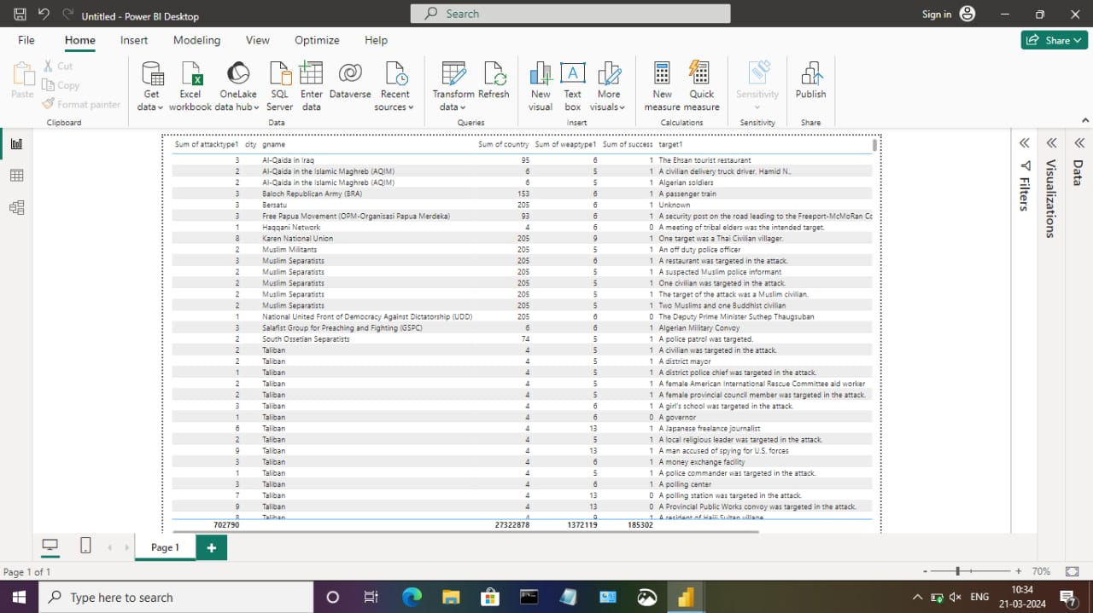

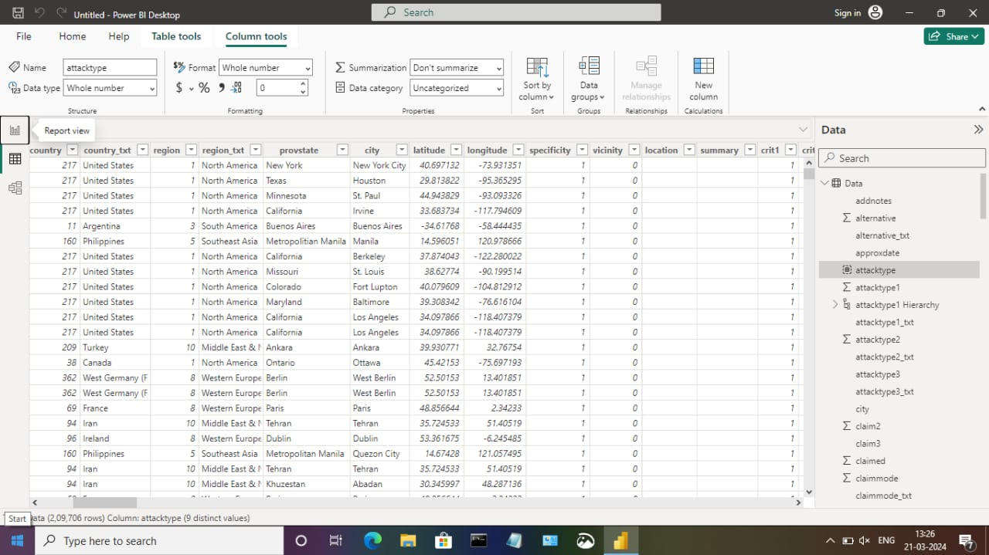

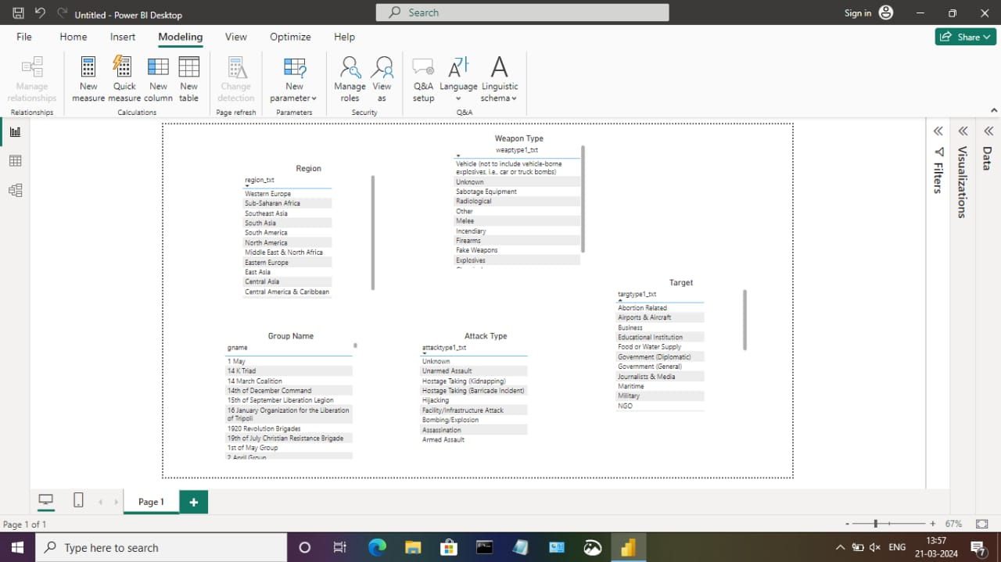

***Dash board***

***POWER BI POWERED GLOBAL TERRORISM DATASET ANALYSIS***

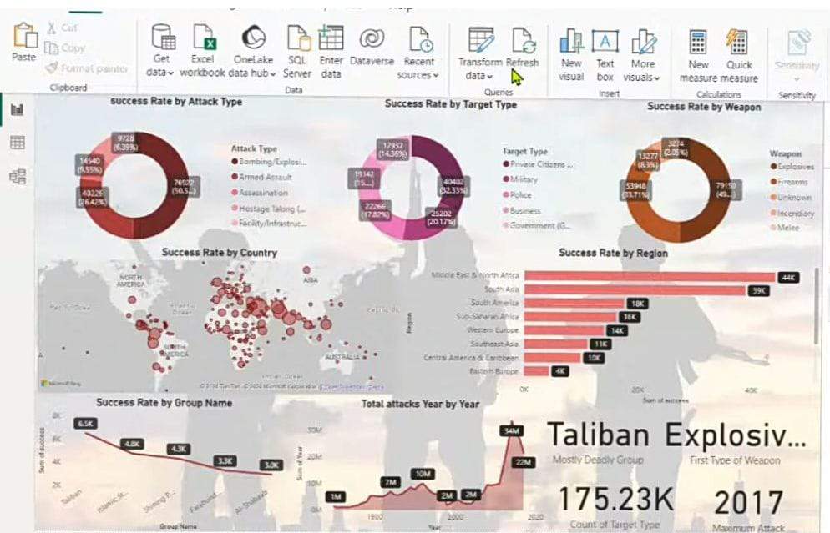

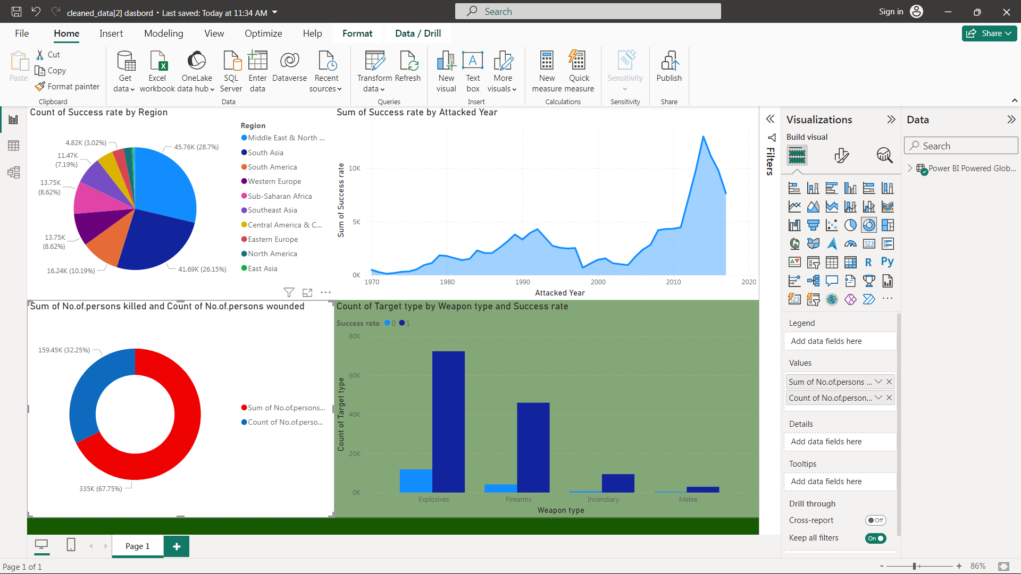

# *5. CONCLUSION*

***"The project 'Global Terrorism Analysis' leveraging Power BI has effectively showcased the transformative potential of data analytics in understanding and combating terrorism worldwide. By analyzing the dataset in real-time, we have gained invaluable insights into the intricate dynamics of terrorist activities, enabling proactive decision-making and strategic planning. The interactive dashboards and reports have provided a holistic view of terrorism trends, facilitating the identification of key patterns and risk factors. This enhanced analytical capability not only bolsters security measures but also empowers stakeholders to devise targeted interventions and policies. Moreover, the project underscores the significance of data visualization in simplifying complex information and fostering actionable insights. Through the intuitive interface of Power BI, we have successfully translated raw data into visually compelling narratives, empowering stakeholders to navigate and comprehend critical information effectively. Ultimately, this project signifies the pivotal role of data analytics in safeguarding global security and fostering informed responses to emerging threats."***

# *6. FUTURE SCOPE*

*.*

***"The future scope of analyzing global terrorism datasets using Power BI is expansive. With advancements in analytics and machine learning, Power BI can predict future trends in terrorist activities based on historical data. By incorporating predictive analytics, stakeholders can anticipate emerging threats and proactively implement counterterrorism measures. Moreover, Power BI's ability to integrate with diverse data sources opens avenues for incorporating additional datasets, offering a comprehensive understanding of terrorist activities worldwide. As data privacy and security are paramount, future iterations of this project should prioritize robust data governance strategies to ensure the secure handling of sensitive information while adhering to regulatory requirements. Additionally, exploring the integration of real-time data streams can provide timely insights, revolutionizing how stakeholders respond to terrorist threats and potentially enhancing global security measures."***

**7. REFERENCES**

***Microsoft Power BI Documentation: <https://docs.microsoft.com/en-us/power-bi/>***

***National Consortium for the Study of Terrorism and Responses to Terrorism (START). (n.d.). Global Terrorism Database (GTD). Retrieved from <https://www.start.umd.edu/gtd/>***

***Microsoft Power BI Blog: <https://powerbi.microsoft.com/en-us/blog/>***

***7. Link***

***https://github.com/Vengadeshrupa/Power-BI-Powered-Global-Terrorism-Dataset-Analysis.git***